catalogue

Product overview 2
1. parameter 2
2. IC TYPE 2
3. Junction description 3
4. DMX512 DAT-A CLK-B 3
Animation software operation 3
1、NEW 3
2、Select Controller Model 4
3、Add pixels 4
4、Animation recording 5
5、OUT SD Files 6
File down to RJ-USB-500 7
1. Administrator permission to open down_flash 7
2. Successful connection lights flicker 7
3. open file 8
4. down 9

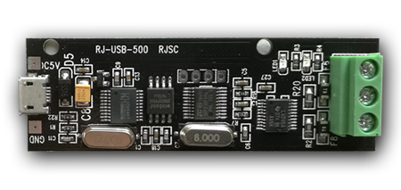

一、Product Overview

Parameter

Power Supply | DC5V
Specifications | L75XW23.6XH14 (mm)
Max Pixels | 512

IC
WS | WS2811 /2812
TM | TM1804/1812/DMX512
UCS | UCS1903/2903/DMX512
GS8206 | GS8206
SK6812 | SK6812
DMX512 | DMX512

RGB/RGBW/W

Wiring
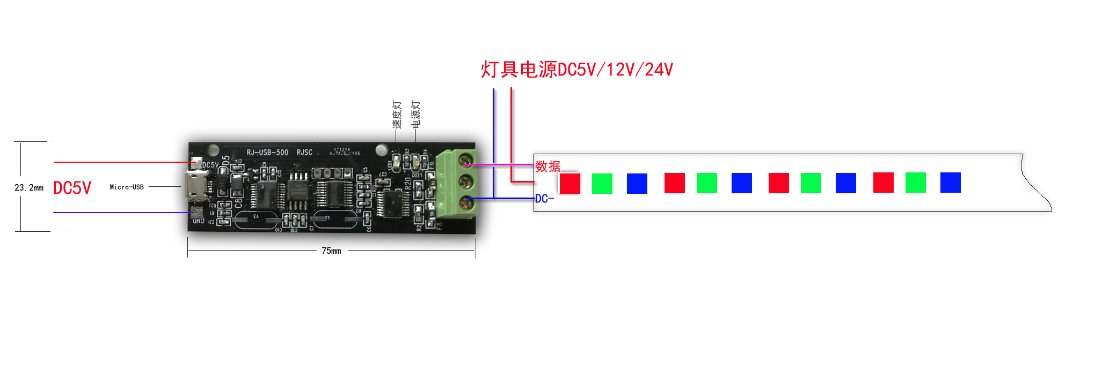
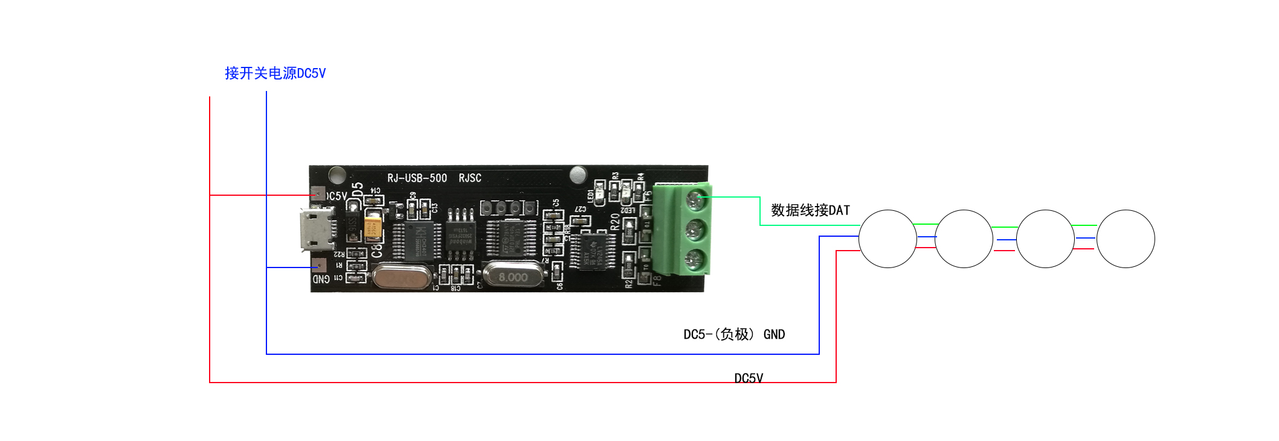

When connect to DMX512 signal，DAT-A CLK-B。

二、Soft
ew
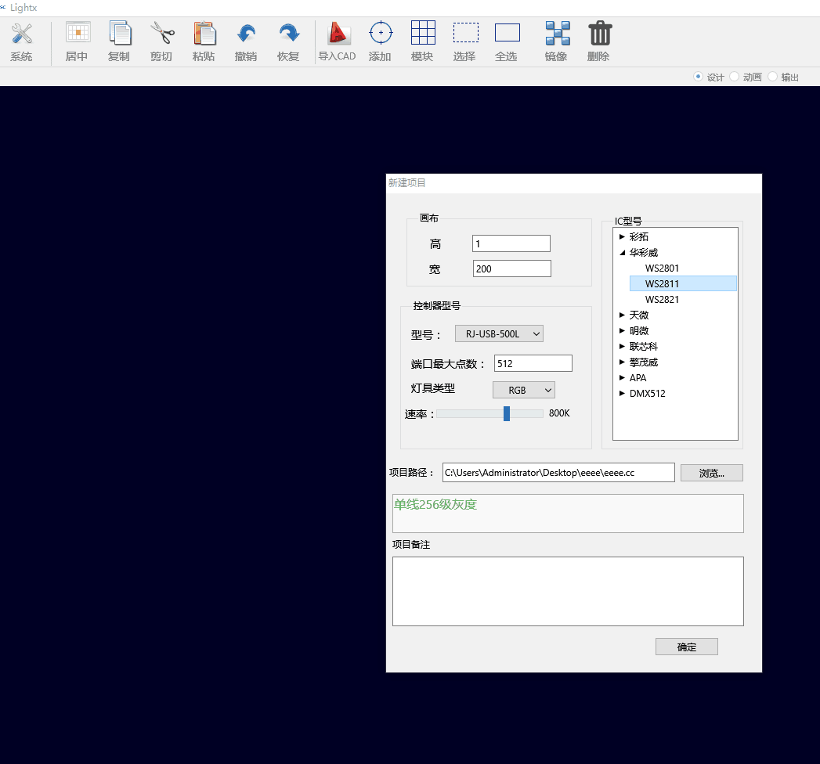

Select Controller Model
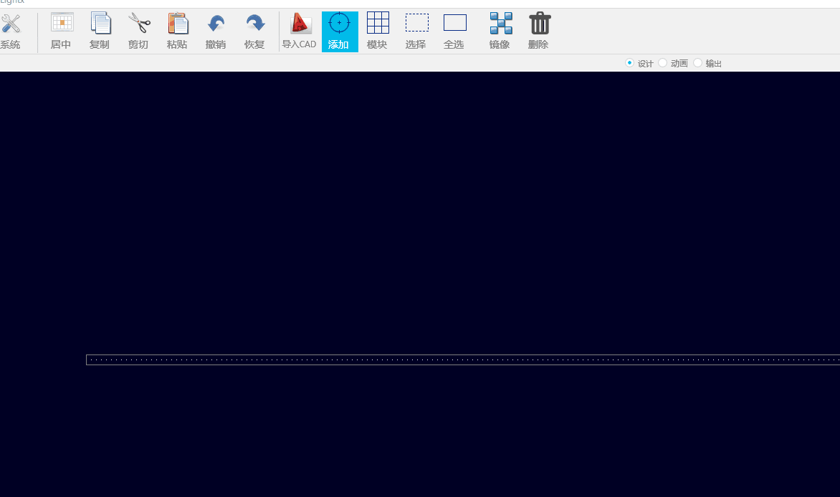

3、Add pixels
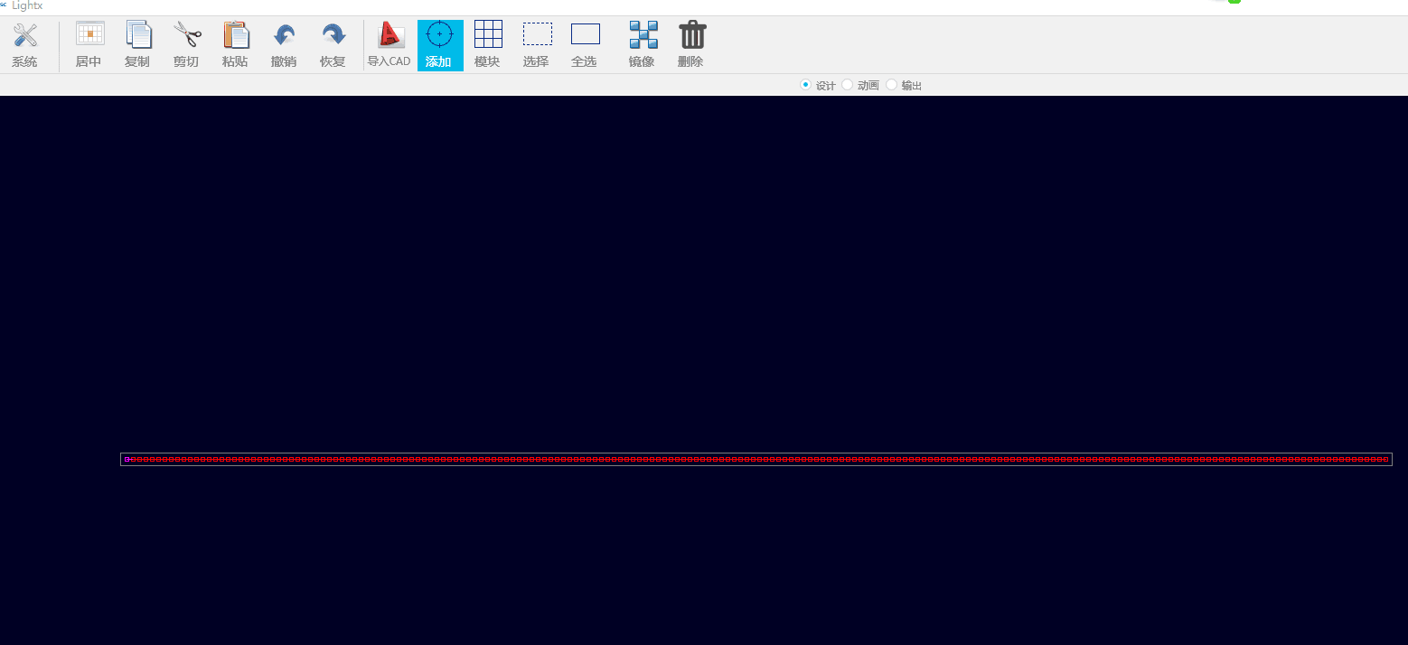

4、Animation recording
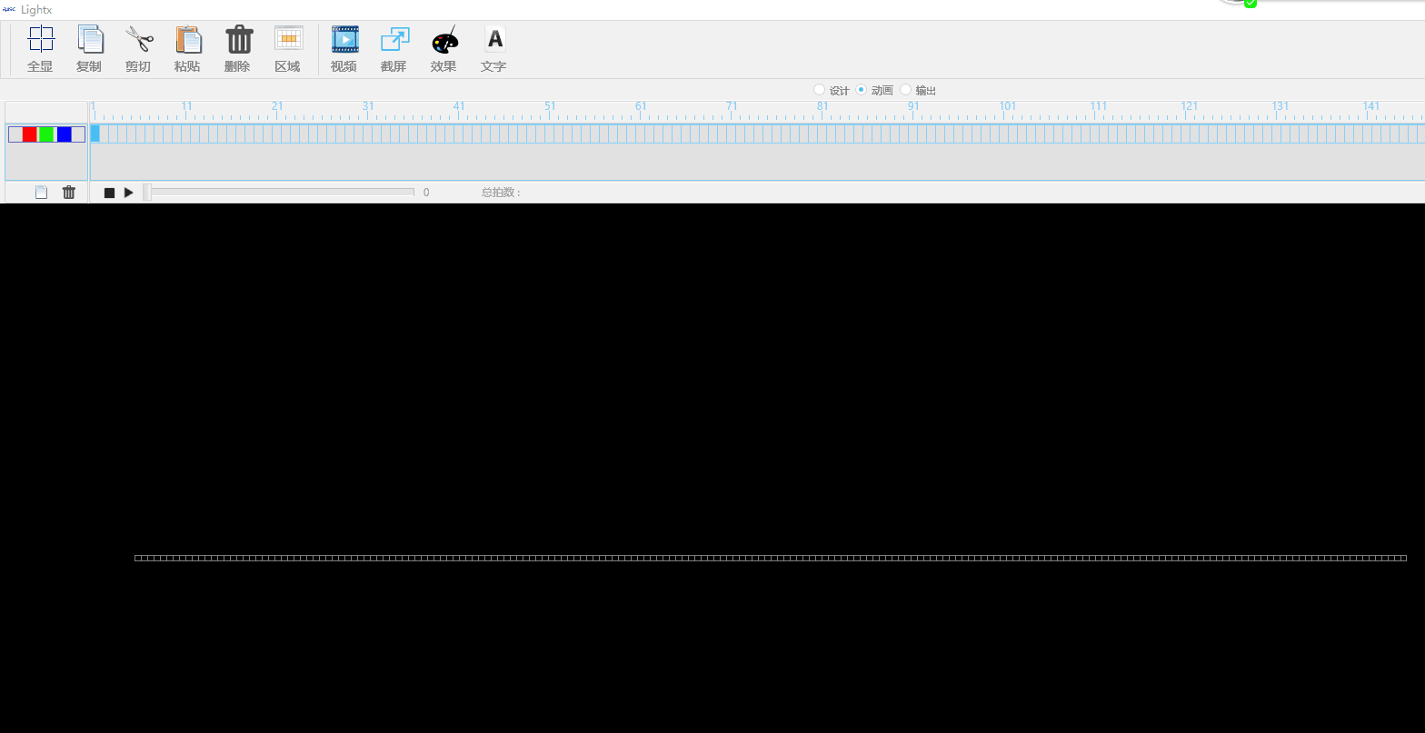

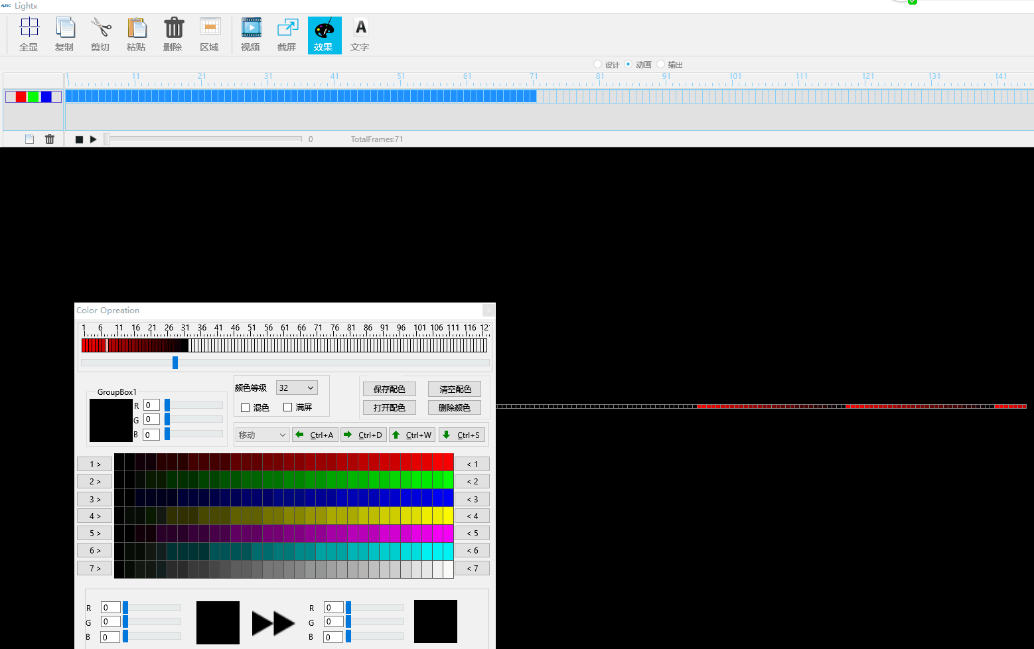

5、Out SD file
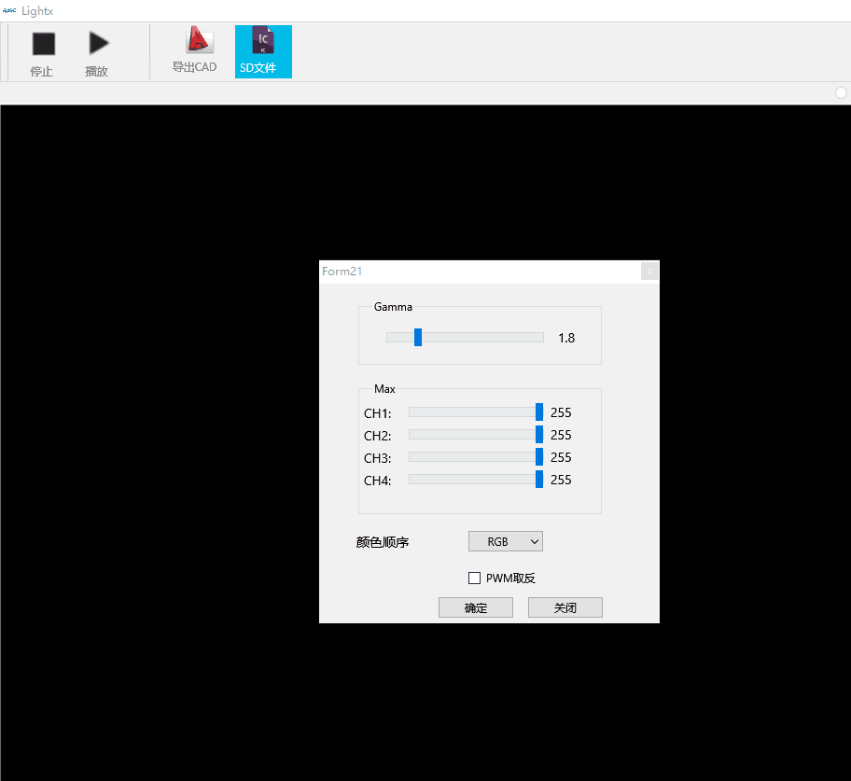

- File down
- the first time the computer runs the software, it must be install driven

Administrator permission to open down_flash
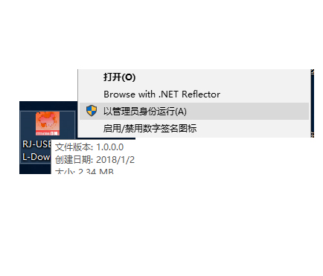

Successful connection lights flicker.
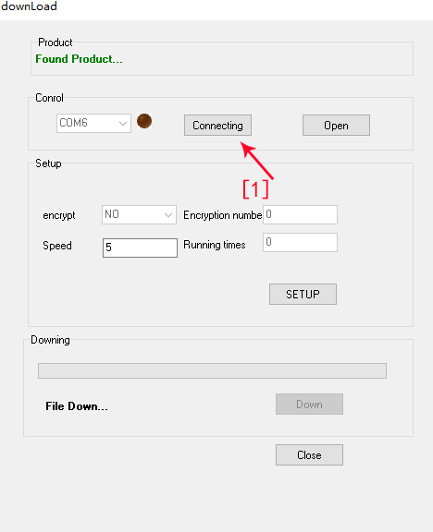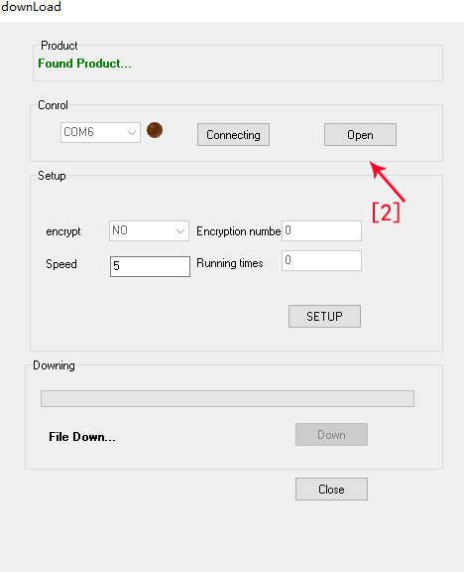

Open File

Down

